DevOps Project
The customer would like an on-line system to enter customer details for flights. The system would then calculate the cost based on business or personal class and produce a cost of the flight for the clients. The system should be clean and simple. The system needs to consider the usual personal details and frequent flyer details. Where the client regularly travels outside of Europe and the US it should be noted. The administrator should be able to access detailed information and edit as appropriate. Once the client enters details it should not be able to be changed by the client.

The system should be clean and simple. Take note of where the customer is travelling to. The admin should be able to access and edit information. The client cannot. Security and performance is key. Include a session timeout feature within the system.
Tasks Database Calculations
Jacoco (Cathal) Mongo (Caolan) Webservice (?)
Junit (Team) Server () GUI/HTML (Tristan)
Jira (Team) PHP ()
Jconsole/Jrat (Tristan)
Javadoc (Shaun)
Git/Github (Kate)
Scrum (Team)
Conclusions (Team)

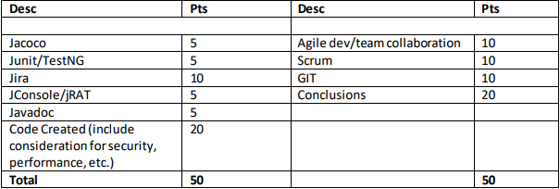

First Scrum: 12/10/2017